## ABSTRACT

Card games usually maintain an outstanding balance between skill and chance, which is what makes them so appealing. **UNO** Online is a trick-taking card game that is played using a standard 108 cards with no Joker.

**UNO** is one of the world-wide well-known and popular card games. It is the classic and beloved card game that’s easy to pick up and impossible to put down! This game is played by matching and then discarding the cards in one’s hand till none are left.

Players take turns matching a card in their hand with the current card shown on top of the deck either by color or number. Special action cards deliver game-changing moments as they each perform a function to help you defeat your opponents. These include skips, reverses, draw two’s, color-changing wild and draw four wild cards. With the 108 game cards available, each player has to discard a card when his turn comes. Every player’s intention is to have as less cards as possible to win the game. The player has to draw four cards when the big name UNO is not spelled when the player is about to discard last second card. This game is based on how we use the cards available by using

our IQ to the fullest to win over the other players.

This game can change at any moment with the player. The player who seems to be winning could lose at any point of time. Anything is possible in this game. The main logic behind winning the game is to use the cards available and place the right card at the right time to win the hand. Here we have used Front end Technology as React Js and Back end as node Js.

**TABLE OF CONTENTS**

1. INTRODUCTION 1

1.1 Overview 1

1.2 Proposed Method 4

2. LITERATURE SURVEY 5

3. SYSTEM REQUIREMENTS SEPCIFICATION 11

3.1 Software Requirements 14

3.2 Hardware Requirements 14

4.SYSTEM DESIGN 15

4.1 Class Diagram 18

5. METHODOLOGY 18

5.1 Module 1:Starting a game 18

5.2 Module 2: Distribution of cards 20

5.3 Module 3: In-Game Chat Box 22

5.4 Module 4: Invalid Move 23

5.5 Module 5: Draw card 24

5.6 Module 6: Draw 2 cards 25

5.7 Module 7: wild card 27

5.8 Module 8: Draw 4 cards 27

6. IMPLEMENTATION 29

7. TESTING 35

8.CONCLUSION AND FUTURE SCOPE 38

9.REFERENCES 39

**LIST OF FIGURES**

Error! Bookmark not defined.

Figure 1.1: UNO game logo…………………………………...1 1

Figure 1.2: Set of number cards………………………………..2

Figure 1.3: Draw 2 card………………………………………...2

Figure 1.4: Wild Card 3

Figure 1.5: Draw 4 Wild Card 3

Figure 2.1: Play-UNO.com 5

Figure 2.2: Uno Freak.com 6

Figure 2.3: Crazy games 6

Figure 2.4: 4 Colors on Poki 7

Figure 2.5: Halloween Multiplayer Uno 8

Figure 4.1: Class Diagram for UNO game 15

Figure 4.2: Association between player and Cards 16

Figure 5.0: Methodology 17

Figure 5.1.1: Start game page 18

Figure 5.1.2: Player 1 waiting page 18

Figure 5.2.1: Distribution of cards to players 19

Figure 5.2.2: Change to blue color based on discarded card 19

Figure 5.2.3: Change to red color based on discarded card 20

Figure 5.2.4: Change to yellow color based on discarded card 20

Figure 5.3.1: In-Game ChatBox 21

Figure 5.4.1: Invalid move for player 1 21

Figure 5.4.2: Invalid move for player 2 22

Figure 5.5.1: Drawn Card is played 22

Figure 5.6.1: Draw 2 cards for player 1 23

Figure 5.6.2: Draw 2 cards for player 2  23

Figure 5.7.1: Wild Card  24

Figure 5.8.1: Draw 4 Wild Card  25

Figure 6.1: Hierarchy of project  26

Figure 6.2: App Start Code 27

Figure 6.3: Home Page Code 27

Figure 6.4: Components of game page code 28

Figure 6.5: Components of game pages 29

Figure 6.6: CSS Code 29

Figure 6.7: Server Code 30

Figure 6.8: Users code 31

Figure 7.1: Server Start 32

Figure 7.2: Player 1 waiting in waiting room 32

Figure 7.3: Discarding a card 33

Figure 7.4: Change of color to red basing on discarded card 33

Figure 7.5: Choose Color as wild Card is discarded 34

Figure 7.6: In-Game Chat Box 34

1. **INTRODUCTION**

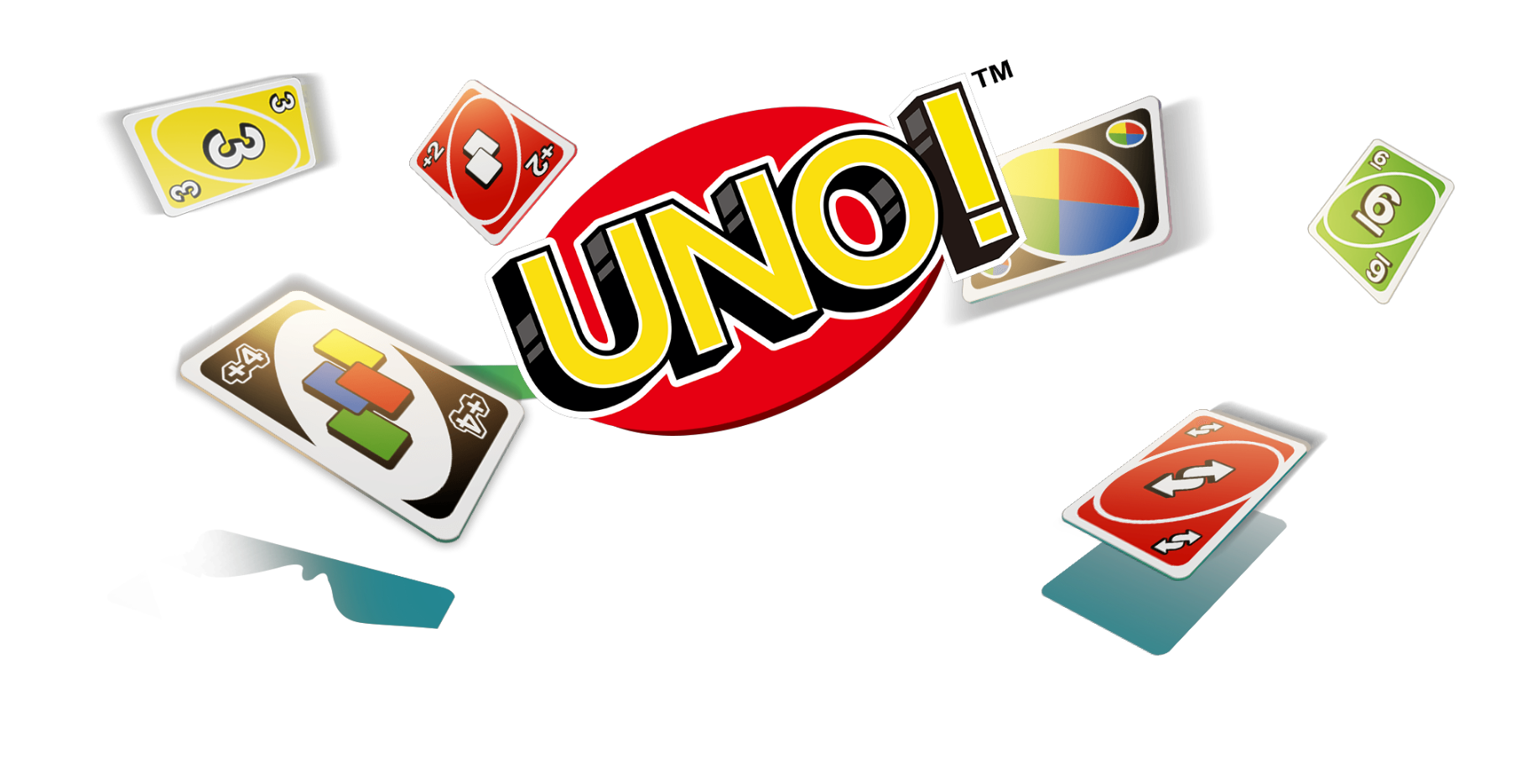The **UNO** game is based on how we use the cards available by using our IQ to the fullest to win over the other players. After the cards are distributed, each player must discard a card matching either color or number on discarded card. They must have zero cards before other player wins. Using the availability of special cards, the player can change the game at any point of time. The purpose of the round is to get rid of as many cards as possible to win the game.

### Overview

**Fig 1.1 UNO game logo**

UNO is a world-wide most famous game enjoyed by almost all teenager. The game is about getting rid of as much cards as possible before other players. Every player has a chance to change the game at any point of time with available special card abilities. A special card could be a skip, Reverse, Draw4, Draw2, Wild card. Each card has its special abililty. Going through each special card ability:

A **UNO** deck consists of 108 cards, of which there are 76 Number cards, 24 Action cards and 8 Wild cards. **UNO** cards have four color "suits", which are red, yellow, blue and green Each color contains 19 cards, one number 0 card and two sets of cards numbered 1-9

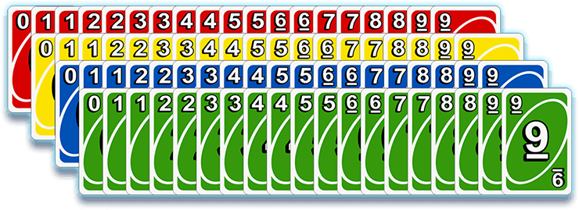

**Fig 1.2 set of number cards**

### Action Cards

There are two of each action card in each color, they are: Draw 2 (the next player must draw 2 cards and miss their turn), Reverse (reverses the direction of play) and Skip (the next player is "skipped").

### Draw 2 card

The next player must draw 2 cards and miss the turn.

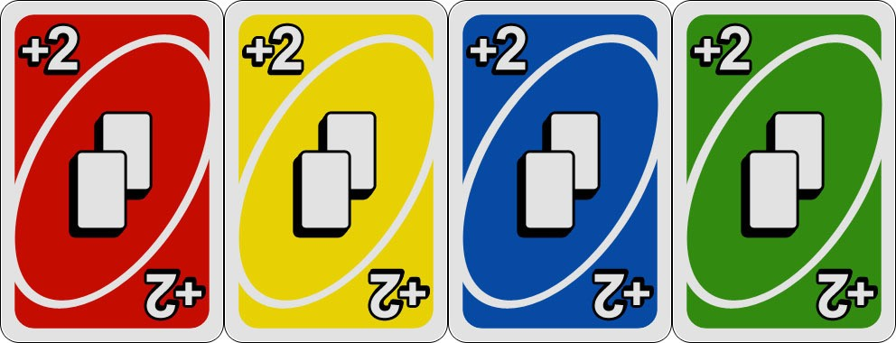

**Wild Card**

**Fig 1.3 draw 2 card**

Wild Cards include Wild (change color) and Wild Draw 4 (change color and the next player must draw 4 cards). Players can play them anytime and change the color that continues play. There are 4 of each kind of Wild Cards

* **wild**

Play this card to choose the color that continues play

**.**

### wild draw4

**Fig 1.4 wild card**

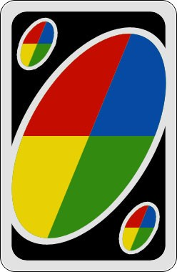Play this card to choose the color that continues play plus the next player must draw 4 cards and lose their turn.

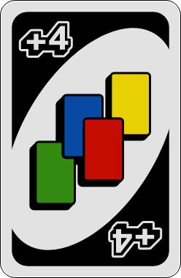

**Fig 1.5 draw 4 wild card**

After the cards are distributed, each player must discard a card matching either color or number on discarded card. They must have zero cards before other player to win. Using the availability of special cards, the player can change the game at any point of time. The purpose of the round is to get rid of as many cards as possible to win the game.

### Proposed Method

In this project, the gameplay of UNO consists of each player taking turns that consist of either matching the upmost face-up card in the stack or playing one of the special cards. At the beginning of their turn, a player can match either the number or the color of the face-up card with a card in their hand. If the card is matched, play continues to the next player. If the player does not have a matching card but has a Wild Card or Wild Draw 4 Card in their hand, they can choose to play the card. Wild cards allow the player to choose any color.

The player must take the topmost card from the draw pile if they cannot play a card from their hand. If the drawn card cannot be played, they continue taking cards from the draw pile until they can play a card. The player is not forced to play a matching card from their hand. They can choose to play a Wild card or take a new card from the draw pile. If the player elects to draw cards, they must continue drawing until they receive a playable card. They cannot play a card that was originally in their hand after choosing to take a card from the draw pile. After the player matches the face-up card, play continues to the next player.

At the start of the game, play continues to the left of the player in a clockwise direction. As the name implies, the Reverse card will change the direction of the next player from left-to-right or right-to-left. A Reverse card played in a two-person game acts like a Skip card. If the last card is taken from the draw pile, all of the cards that have been played except the topmost face-up card should be shuffled and used as a new draw pile. This can continue as many times as it may take for someone to finally run out of cards in their hand is declared as winner of the fame.

## LITERATURE SURVEY

Various methods and implementation for UNO online game are live on internet. Few of them are mentioned below:

### Play-Uno.com

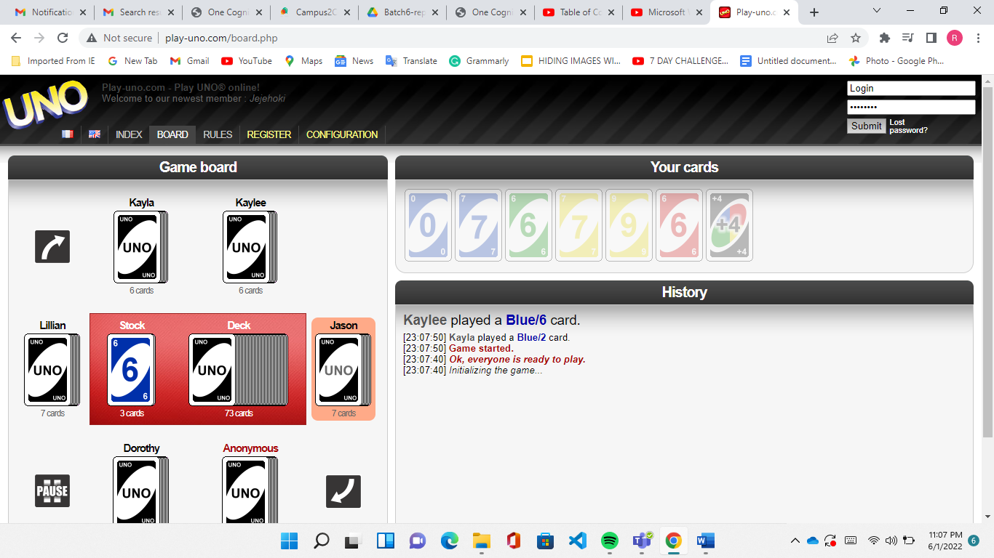

**Fig 2.1: Play-UNO.com**

Play-Uno.com[1] is a unique way to play the game because it offers a wide

range of options for play via AI player. You can either register for a free account or play anonymously, though you won't be able to be eligible for the leaderboard if you don't enter. You can play with anywhere from five to nine adversaries and with options for seven through 11 cards. You can also choose from five game speeds, ranging from very slow to very fast. You'll just need an internet connection to play.

### Uno Freak

### 

**Fig 2.2.: UNOFREAK.com**

Uno Freak[2] also allows you to either register for a free account or play as a guest, although like Play-Uno.com, you aren't eligible for placement on a leaderboard unless you have an account. On Uno Freak, you can enter virtual rooms to play live against others or play against AI players. In addition to the leaderboards and stat features, there is also a messenger feature. You only earn points from playing against other live players, not bots. You can play directly in your browser, so you just need access to the internet

### Crazy games

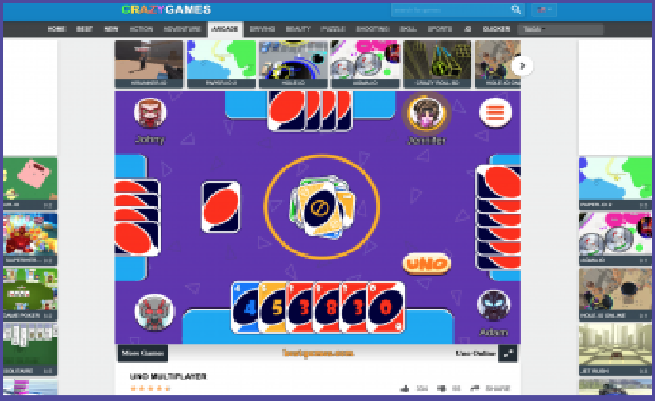

**Fig 2.3: Crazy games**

Crazy Games[3] offers options to play Uno in online multiplayer mode or against computer players. You can play with up to four random opponents. Turns are timed during play, so you'll lose your turn if you run out of time. You can also choose a fun profile pic. There are no downloads or specific platforms required, so you can play anywhere you have an internet connection.

### 4 Colors on Poki

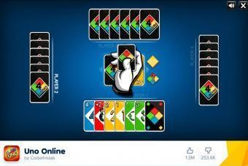

**Fig 2.2 Colors on Poki**

This game is played between two, three, or four computer-generated opponents. It has an easy-to-use format with simple rule explanations shown at the start of the game. There are no timed turns, so it's a fun

option if you need something to do in between other tasks. Sound is optional. The game only requires an internet connection.

### Halloween Multiplayer Uno

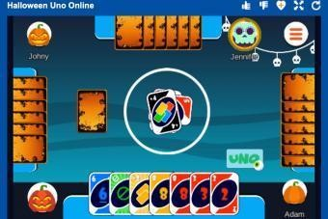

**Fig:2.3 Halloween Multiplayer UNO**

The Halloween game[5] is free to play, but it will feature ads before allowing you to start playing the game. To start, you'll enter a player name and choose a fun Halloween profile picture. Then, choose whether to play an online multiplayer version of the game or against computer players. Play against two, three, or four other players. Turns are timed. Like the other web games mentioned, it just requires an internet connection.

### Official Uno Game From Ubisoft

The official Uno game from Ubisoft[6] is available for Playstation, Xbox, Nintendo Switch, and PC for $10. Online multiplayer is a standard option with the current game, allowing you to interact with friends or other players worldwide. You can chat with other players using voice support, or enable video chat so you can see friends face to face. Additional features such as leaderboards and virtual medals encourage user competition and interaction. You can play with standard Uno rules or set up your own

"house rules" when you play with others. There is a limited free trial available.

### Uno for PC

You can also get the PC version of Uno available via digital download. It requires a 64-bit operating system compatible with Windows 7, Windows 8.1, or Windows 10. You'll also need a 4 GB Ram and NVIDIA GeForce GTS 450 or AMD Radeon HD 5670 graphics card (or equivalent). A broadband internet connection is required to access the multiplayer features.

### Uno for Playstation 4

Uno is available for Playstation 4, though you must have a Playstation account enabled to use the interactive features to play online with other people. When you purchase the PS4 version, you'll also get access to a free Playlink that will allow you to play the game on mobile devices.

### Xbox One

The Xbox One version of Uno requires an Xbox Live Gold account (sold separately) to access online play with others and the social and interactive features of the game.

### Uno App From Mattel

Another option to play the official Uno game[7] with friends or other players is with Uno Live! app from Mattel. The app is free to download and use on a mobile device, but you'll need a wireless data plan or WiFi connection to play. The app allows you to play online with friends, and you can even set up private rooms and set your own house rules. A unique feature is that you can also team up with friends to play partner Uno games against others. Other features include tournaments and leaderboards.

## SYSTEM REQUIREMENTS SEPCIFICATION

A System Requirements Specification is a structured collection of information that embodies the requirements of a project. The Implementation of the project design can be divided into two sections; Hardware and Software implementations. The hardware implementation mainly includes having the right device, which in our case is a PC since it is a web application. The system is OS compatible, hence that’s not something to be worried about. The software implementation plays a major role. The software implementation includes:

* Development of frontend.
* Development of backend.
* Integrating all the above said components.

### Software requirements

Software requirements establish the agreement between your team and the customer on what the application is supposed to do. Without a description of what features will be included and details on how the features will work, the users of the software can't determine if the software will meet their needs**.** The key software requirements required for the project are:

Virtual Studio Code Npm

Node js React

### Virtual Studio Code

Visual Studio Code is a source-code editor that can be used with a variety of programming languages, including Java, JavaScript, Go, Node.js, Python, C++ and Fortran. It is based on the Electron framework, which is used to develop Node.js Web applications that run on the Blink layout engine. Visual Studio Code employs the same editor component (codenamed "Monaco") used in Azure DevOps (formerly called Visual Studio Online and Visual Studio Team Services).

Out of the box, Visual Studio Code includes basic support for most common programming languages. This basic support includes syntax

highlighting, bracket matching, code folding, and configurable snippets. Visual Studio Code also ships with IntelliSense for JavaScript, TypeScript, JSON, CSS, and HTML, as well as debugging support for Node.js. Support for additional languages can be provided by freely available extensions on the VS Code Marketplace.

Visual Studio Code is **a streamlined code editor with support for development operations like debugging, task running, and version control**. It aims to provide just the tools a developer needs for a quick code-build-debug cycle and leaves more complex workflows to fuller featured IDEs, such as Visual Studio IDE.

* + - **NPM**

**npm** (originally short for **Node Package Manager**) is a package manager for the JavaScript programming language maintained by npm, Inc. npm is the default package manager for the JavaScript runtime environment Node.js. It consists of a command line client, also called npm, and an online database of public and paid-for private packages, called the npm registry. The registry is accessed via the client, and the available packages can be browsed and searched via the npm website. The package manager and the registry are managed by npm, Inc.

npm is the world's largest Software Registry. The registry contains over 800,000 code packages. Open-source developers use npm to share software. Many organizations also use npm to manage private development.it puts modules in place so that node can find them, and manages dependency conflicts intelligently. It is extremely configurable to support a wide variety of use cases. Most commonly, it is used to **publish, discover, install, and develop node programs**.

### Node js

Node.js is a server-side platform built on Google Chrome's JavaScript Engine (V8 Engine). Node.js was developed by Ryan Dahl in 2009 and its latest version is v0.10.36. The definition of Node.js as supplied by its [official documentation](https://nodejs.org/) is as follows −

Node.js is a platform built on [Chrome's JavaScript runtime](https://code.google.com/p/v8/) for easily building fast and scalable network applications. Node.js uses an

event-driven, non-blocking I/O model that makes it lightweight and efficient, perfect for data-intensive real-time applications that run across distributed devices.

Node.js is an open source, cross-platform runtime environment for developing server-side and networking applications. Node.js applications are written in JavaScript, and can be run within the Node.js runtime on OS X, Microsoft Windows, and Linux.

Node.js also provides a rich library of various JavaScript modules which simplifies the development of web applications using Node.js to a great extent.

### React

React.js is an open-source JavaScript library that is used for building user interfaces specifically for single-page applications. It’s used for handling the view layer for web and mobile apps. React also allows us to create reusable UI components. React was first created by Jordan Walke, a software engineer working for Facebook. React first deployed on Facebook’s newsfeed in 2011 and on Instagram.com in 2012.

React allows developers to create large web applications that can change data, without reloading the page. The main purpose of React is to be fast, scalable, and simple. It works only on user interfaces in the application. This corresponds to the view in the MVC template. It can be used with a combination of other JavaScript libraries or frameworks, such as Angular JS in MVC.

* + - * React JS is also called simply to React or React.js.
      * React.js properties includes the following:
      * React.js is declarative
      * React.js is simple
      * React.js is component based
      * React.js supports server side
      * React.js is extensive

### Hardware Requirements

* **8 GB RAM**

Having a system with 8GB RAM to execute the application will help in smooth and fast response of the website. It helps to explore multiple services and functionalities at the same time effectively.

### PC

Since the project is a web application, the view and working is better experienced in a personal computer, a desktop or a laptop than in a mobile phone or tablet.

* **INTERNET**

It’s important for the device to have internet access in order to explore the services provided by the website.

* **GPU**

The graphics processing unit, or GPU, has become one of the most important types of computing technology, both for personal and business computing. Designed for parallel processing, the GPU is used in a wide range of applications, including graphics and video rendering. Although they’re best known for their capabilities in gaming, GPUs are becoming more popular for use in creative production and artificial intelligence (AI).

## 4.SYSTEM DESIGN

**Unified Modeling Language (UML)** is a general purpose modelling language. The main aim of UML is to define a standard way to **visualize** the way a system has been designed. It is quite similar to blueprints used in other fields of engineering.

 The UML is a very important part of developing object oriented software and the software development process. The UML uses mostly graphical notations to express the design of software projects. Using the UML helps project teams communicate, explore potential designs, and validate the architectural design of the software.

**4.1 Class Diagram**

Class diagram is a static diagram. It represents the static view of an application. Class diagram is not only used for visualizing, describing, and documenting different aspects of a system but also for constructing executable code of the software application

Class diagram describes the attributes and operations of a class and also the constraints imposed on the system. The class diagrams are widely used in the modeling of object oriented systems because they are the only UML diagrams, which can be mapped directly with object-oriented languages.

The purpose of class diagram is to model the static view of an application. Class diagrams are the only diagrams which can be directly mapped with object-oriented languages and thus widely used at the time of construction.

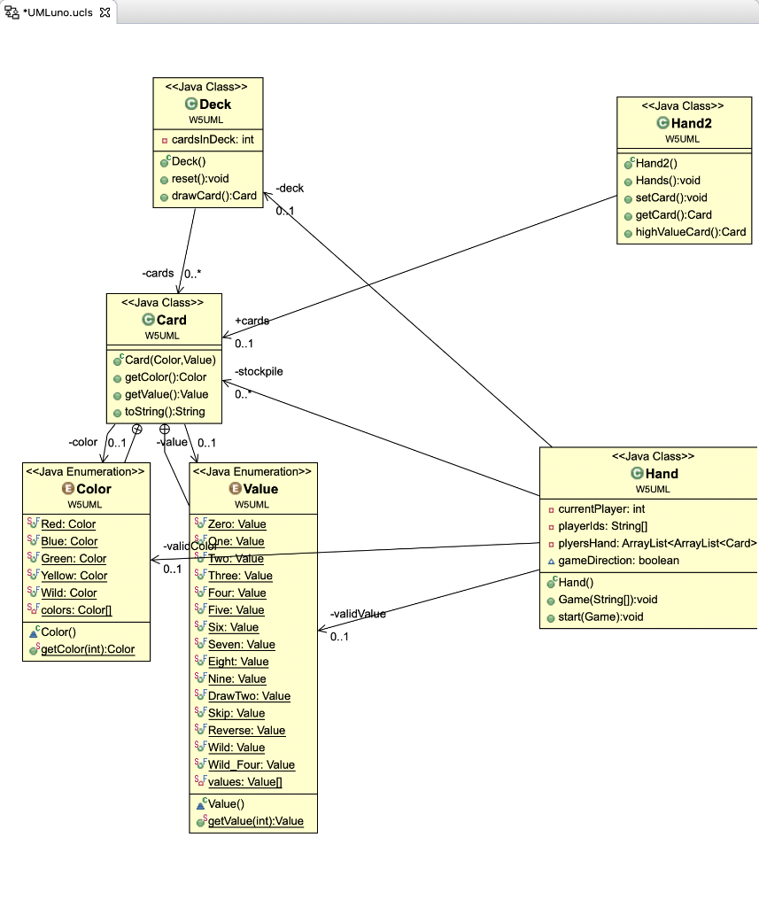

## Fig: 4.1 Class Diagram for UNO game

The associative diagram gives us an image of the relation between player and cards Player has full dependency on cards.

## 

## Fig: 4.2 Association between player and Cards

## 5. METHODOLOGY

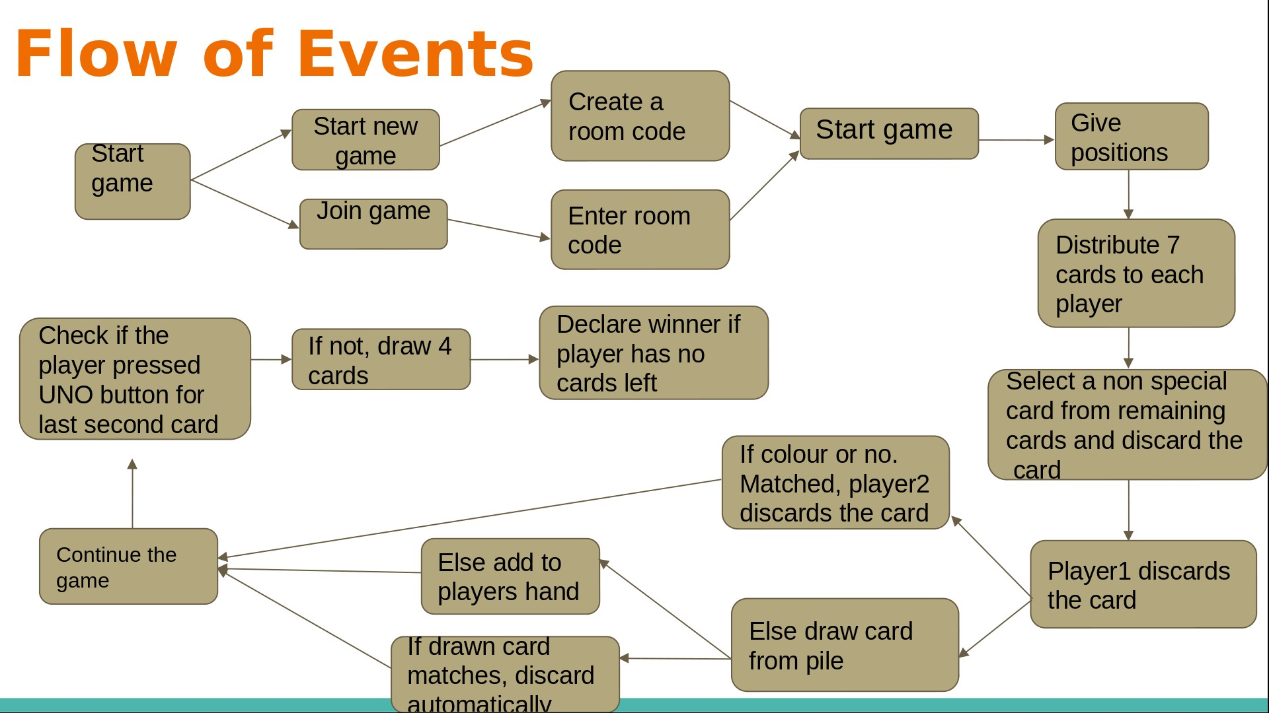The whole project till now is implemented in the following flow as shown in Fig 5.0 Methodology. The outcomes of these modules are given below.

**Fig 5.0 Methodology**

* 1. **Module 1: starting a game**

This is the first module where the expected output is to start the game. Basing on the players is the first player or second. If he is the first player, he have to create a new game which generates a new game code which has to be shared to second player to join. The second player has to enter the game code in the required field to enter the game. Up on validating the game code with active game code, we enter the player to the desk. The player 1 has to wait until the second player comes.

**Sample Outputs:**

The below given images are the sample outputs of the start game

Page and player 1 waiting for the next player to join the game.

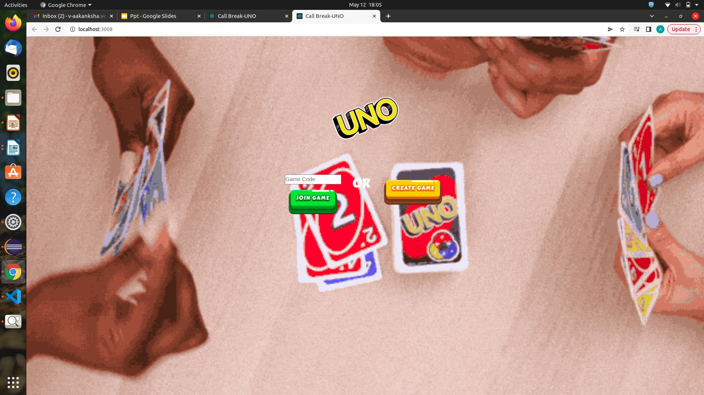

**Fig 5.1.1 Start game page**

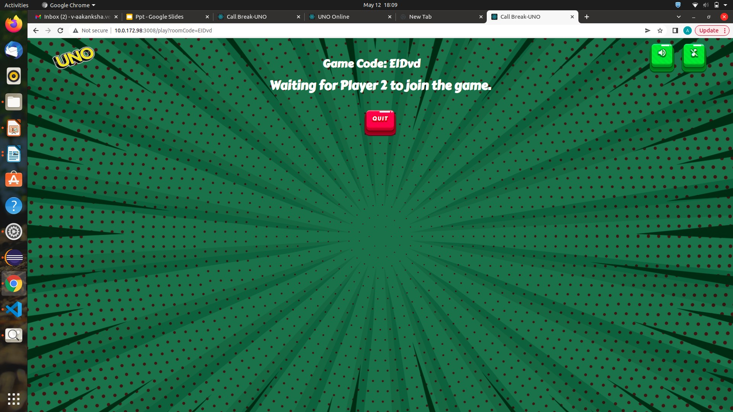

**Fig 5.1.2 player1 waiting page**

### Module 2: Distribution of cards

Once the player2 enters the game, we need to distribute the cards by shuffling and randomly giving seven cards to each player. The cards can include number cards, action cards, wildcards, power cards.

One random card from left over cards is taken and discarded on table. The discarded card is checked if it is any kind of power card. The initial start game card can only be a number card.

Basing on the color of card discarded, the background of application changes accordingly. Like green in below.

**Sample Outputs:**

Images to show distribution of cards and change of background of

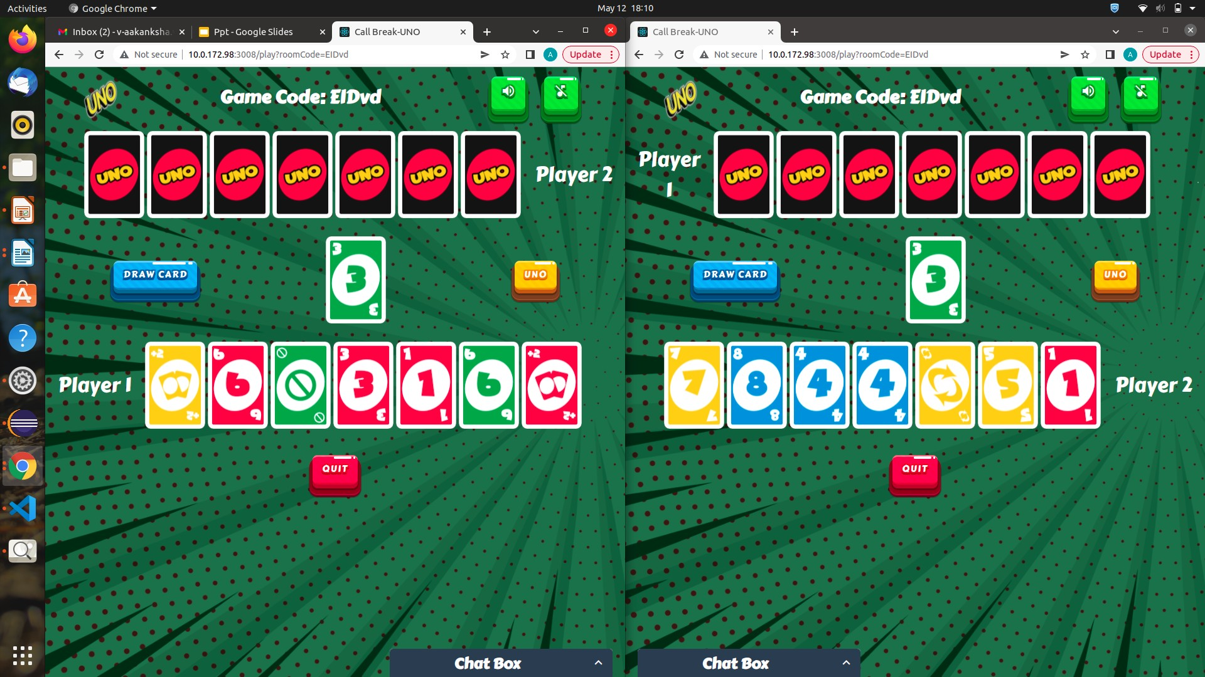Web pages basing on the color of the card on desk at the moment.

**Fig 5.2.1 Distribution of cards to players**

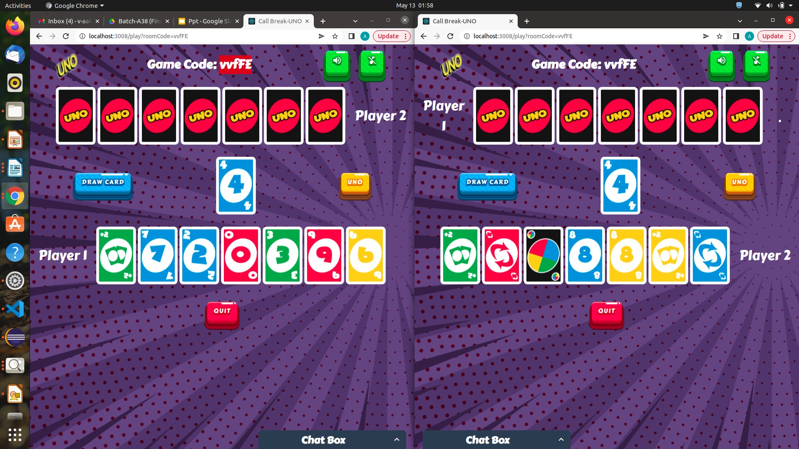

**Fig 5.2.2. Change to blue color based on discarded card**

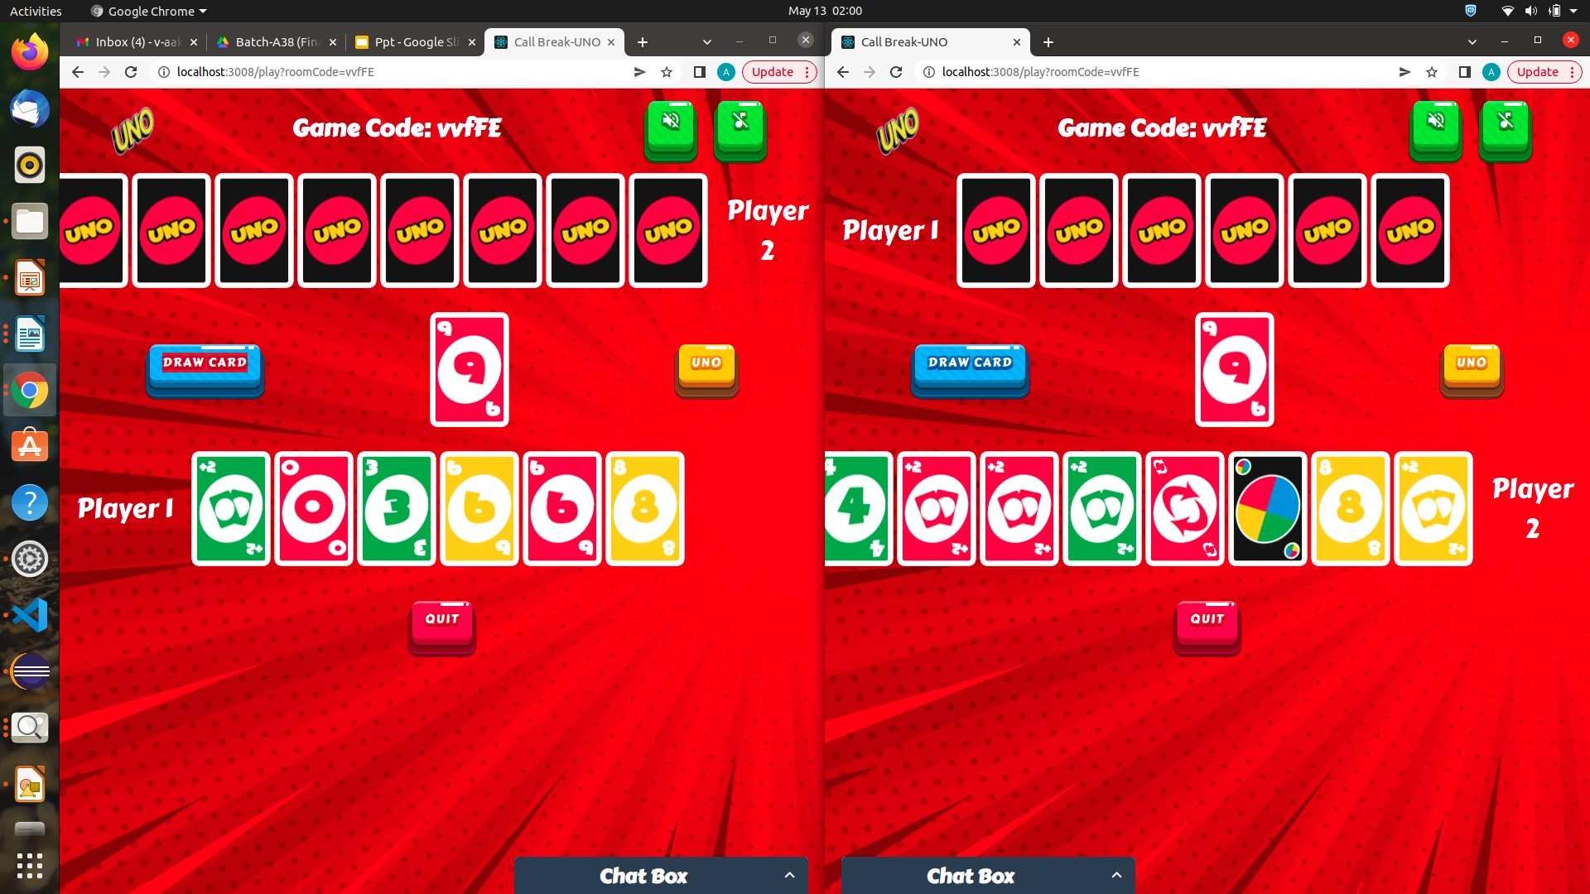

**Fig 5.2.3 Change to red color based on discarded card**

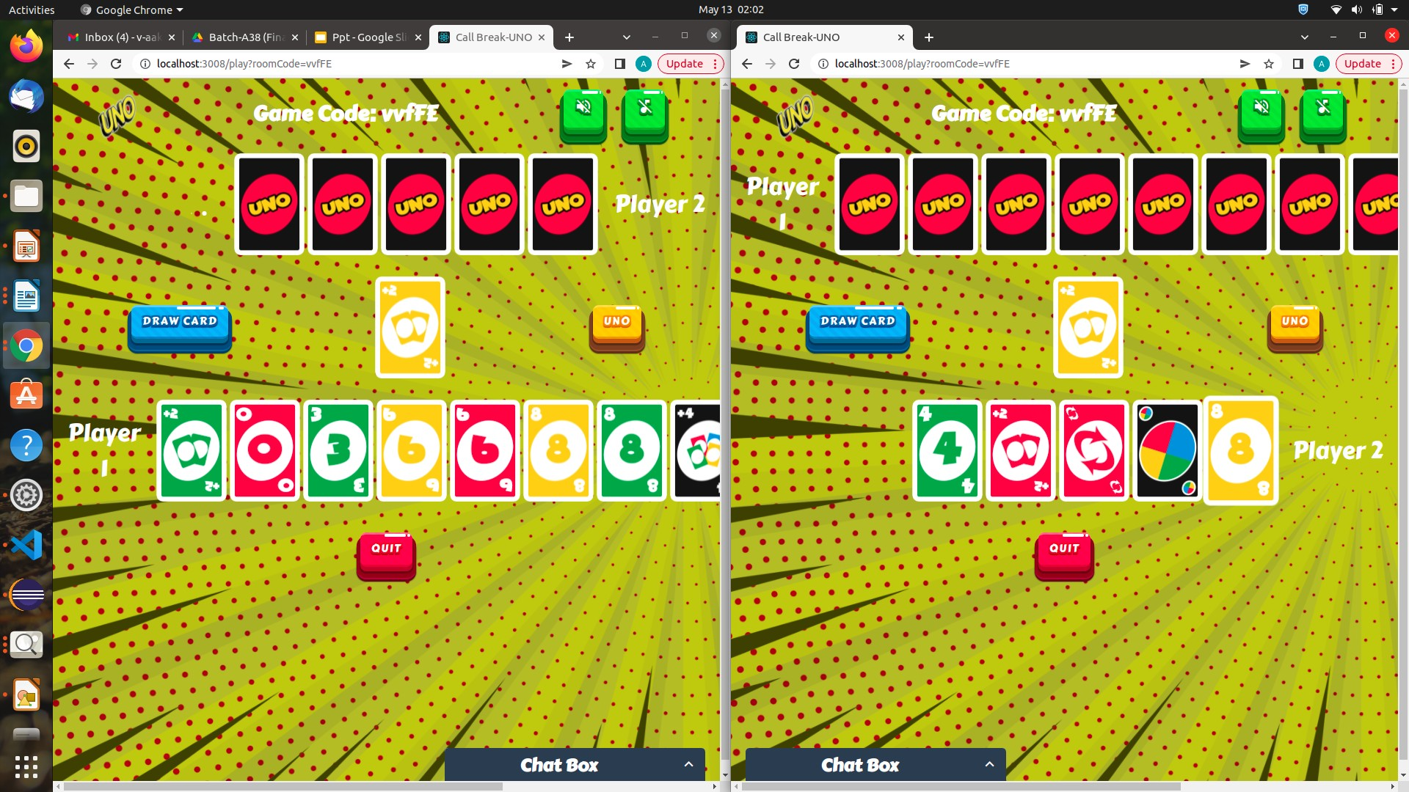

**Fig 5.2.4 Change to yellow color based on discarded card**

### Module 3: In-Game Chat Box

In-game chat is usually text. Players can type message through the game and other people in the game can choose to read or hear it. In-game chat doesn't involve video. You won't be able to see the faces of the people you are chatting with.

The in-game chat lets players say just about anything they like, with some restrictions to make the game experience more enjoyable for everyone.

In-game text chat in most games has some kind of profanity filter built into it, so that players can't ruin the atmosphere with excessive swearing. In-game text chat might also have a 'spam' limiter. Players who post too frequently may get

temporarily blocked from using the in-game chat for 20 to 30 seconds. Players can still play the game while they are blocked from text chatting. Many popular games are including ways to communicate to your team with simple symbols and prepared responses so that you don't have to type or talk to communicate with your team.

**Sample Outputs:**

Image showing the chat window for 2 players on both sides

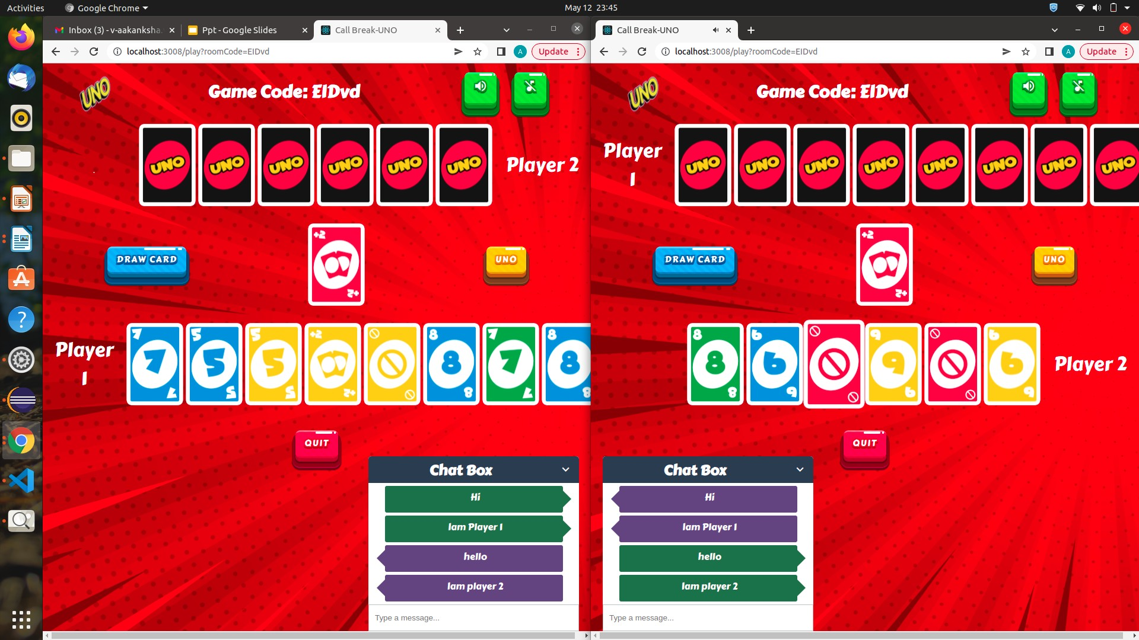

**Fig 5.3.1 In-Game ChatBox**

### Module 4: Invalid Move

when neither the color nor the number on to be discarded card are matching with card on top of desk, then the move is considered as invalid move. When it is an invalid move, we are popping up an message saying the card is invalid. If it is an invalid card the card is drawn.

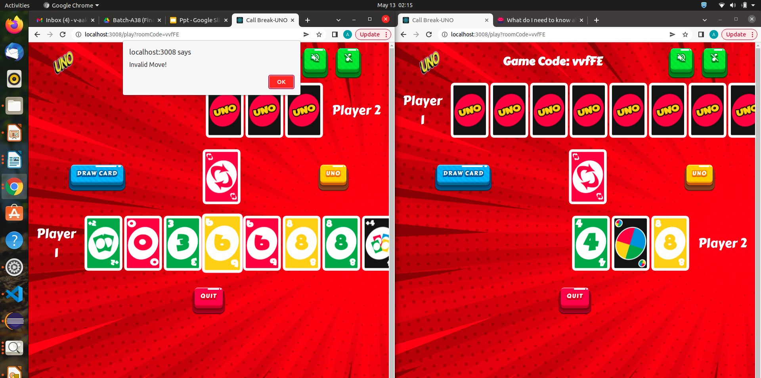**Sample Outputs:**

**Fig 5.4.1 Invalid move for player 1**

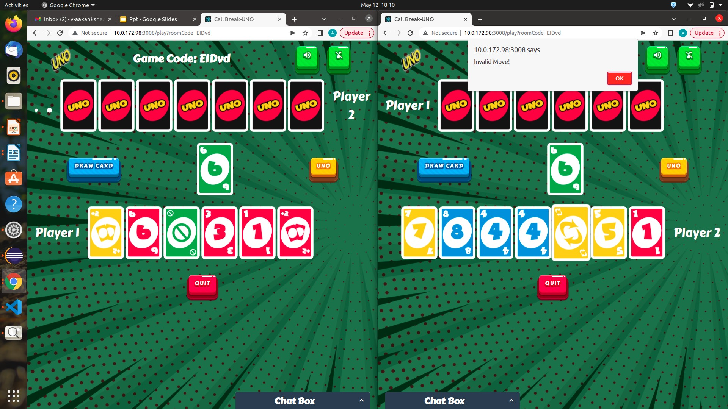

**Fig 5.4.2 Invalid move for player 2**

### Module 5: Draw card

If no color or image is matching, then the player needs to draw a card from the deck of cards. The drawn card can be played automatically when it matches the color or number. This helps the player not to check every time they draw a card. If the drawn card is not matching then the card is added the player’s cards. This leads to increase in number of cards.

**Sample Outputs:**

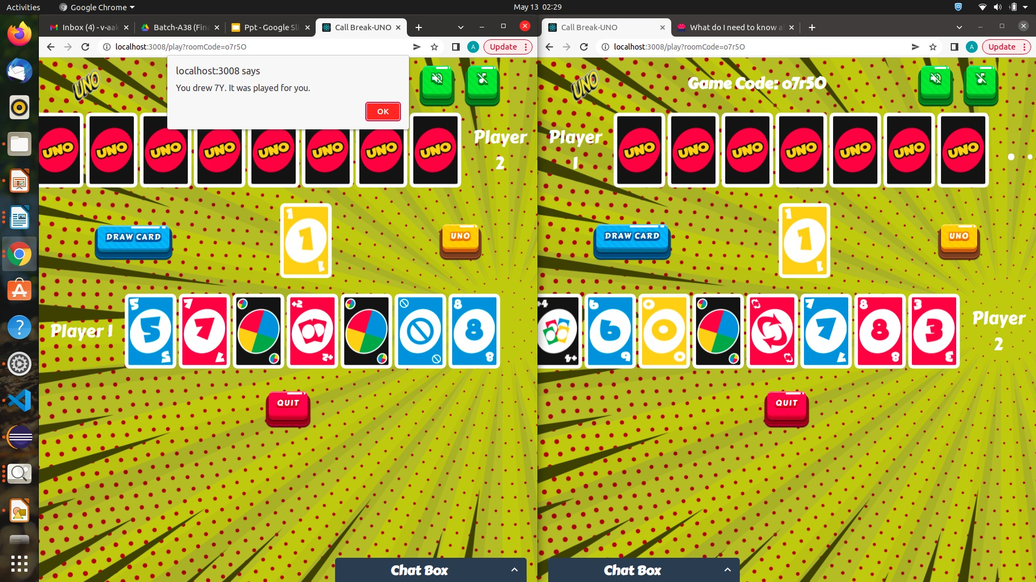

**Fig 5.5.1 Drawn card is played**

### Module 6: Draw 2 cards

when the opponent players discard a draw 2 card, then two cards from the draw card pile are appended to the players hand. This is a plus point to opponent. When this is done, the chances of the opponent raises.

When a person places this card, the next player will have to pick up two cards and forfeit his/her turn. It can only be played on a card that matches by color, or on another Draw Two. If turned up at the beginning of play, the first player draws two cards and gets skipped.

**Sample Outputs:**

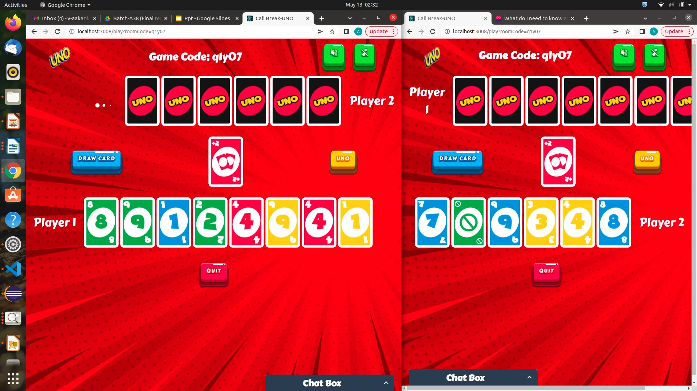 Image showing the draw 2 card for player 1 and player 2 respectfully

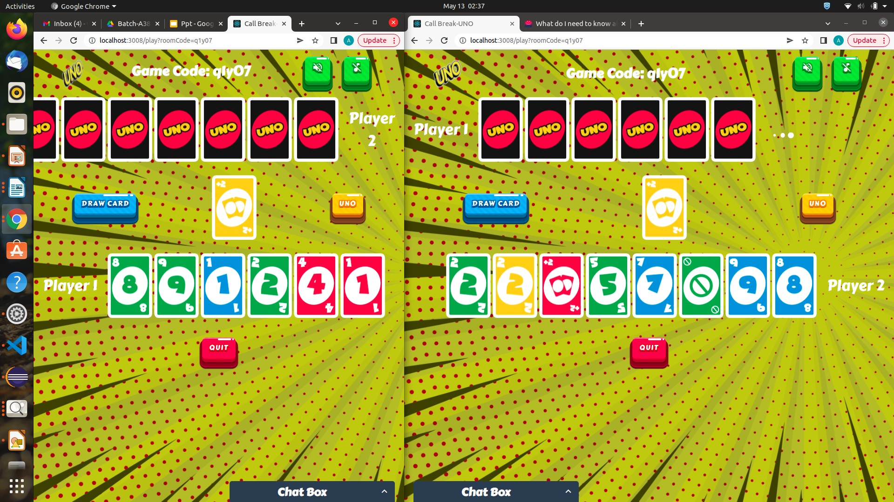**Fig 5.6.1. Draw 2 cards for player 1**

**Fig 5.6.2 Draw 2 cards for player**

### Module 7: wild card

This card represents all four colors, and can be placed on any card. The player has to state which color it will represent for the next player. It can be played regardless of whether another card is available. If turned up at the beginning of play, the first player chooses what color to continue play.

**Sample Outputs:**

Image asking the user to enter a color of his choice as he has choosen Discard a

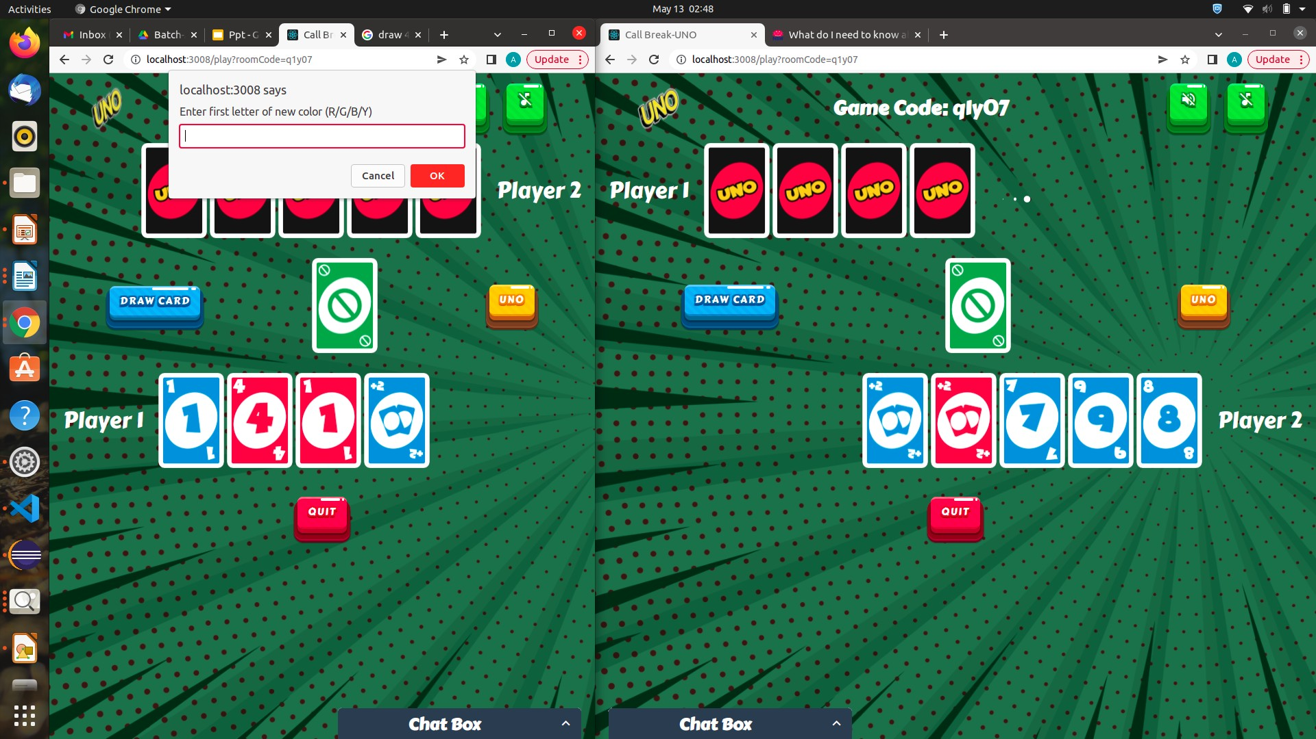 wild card

**Fig 5.7.1 Wild card**

### Module 8: Draw 4 cards

when a "Draw Four" card is put down, the next player must simply draw four cards and lose a turn. The card game company confirmed the rule on Twitter, but people are refusing to accept that it's true. When a player places a Draw 4 card, the next player cannot place another Draw 4 card on top of the one previously played. Instead, a player has to Draw four cards from the Draw pile, and they must to forfeit their turn.

The following rule concerning a Draw 4 card is when to play it during the game. In fact, a Draw Four Card can be played at any time during the game, not only when the player doesn’t have another playable card in hand.

When the Draw 4 card is played, the player gets to choose what color continues the gameplay. Answered below are frequently asked questions about the Uno rules for Draw 4 cards, how they can be played and what actions must be taken.

**Sample outputs:**

Image asking the other player to draw 4 cards as the player has chosen to

discard a draw 4. The current player has to choose a color of his choice as

he has chosen discard a wild card



**Fig 5.8.1 Draw 4 wild card**

## 6. IMPLEMENTATION

## Sample outputs:

## 

## Fig 6.1 Hierarchy of project

## 

## Fig 6.2 App Start Code

## 

## Fig 6.3 Home Page Code

## 

## Fig 6.4 Components of game page code

## 

## 

## Fig 6.5 Components of game pages

## 

## Fig 6.6 CSS code

## 

## Fig 6.7 Server Code

## 

## Fig 6.8 Users code

## 7. TESTING

## The code has been tested at various use cases. All the above given 8 modules in chapter 5 has been tested and verified for correctness. The results of the output were positive and the code has been working in all edge cases as well.

## Sample Outputs:

## Case1: checking if the server has started.

## Fig 7.1 Server start

## Case2: Player 1 waiting to start game until player 2 comes

## Fig 7.2 Player 1 waiting in waiting room

## Case3: Discarding cards according to turns of players.

## Fig 7.3: Discarding a card

## Case4: Change of Color of background based on card discarded

## Fig 7.4: Change of color to red basing on discarded card

## Case5: Player choosing a color when wild card is discarded

## Fig: 7.5 Choose color as wild Card is discarded

## Case6: Chat box for both the players to send and receive messages while playing

## game

## Fig: 7.6 In-Game Chat Box

## 8.CONCLUSION AND FUTURE SCOPE

This game is currently supporting 2 players. We would like to expand this game for multiple players. The game is now capable of having a in-game chat window, music while game running, while a card is discarded. Now In future, this game can be hosted and further and made a website for running. The interface of the game can be improved with color and texture. We would like to add a game with bot. So that a single player could also have fun. Which requires AI and Machine learning to have a wonderful play experience.

## 9.REFERENCES

[1]     H. Iida, N. Takeshita, and J. Yoshimura, “A metric for entertainment of

boardgames: Its implication for evolution of chess variants,” Entertain-

ment Computing Technologies and Applications, pp. 65–72, 2003.

[2]       H. Iida, H. Takahara, J. Nagashima, Y. Kajihara, and Y. Hashimoto, “An

application of game-reﬁnement theory to mah jong,” in International

Conference on Entertainment Computing (ICEC), pp. 333–338, 2004.

[3]       A. P. Sutiono, A. Purwarianti, and H. Iida, “A mathematical theory of

game reﬁnement,” 6th International Conference on Intelligent Technolo-

gies for Interactive Entertainment (INTETAIN 2014), 2014.

[4] N. R. Sturtevant, Multi-Player Games: Algorithms and Approaches.

PhD Thesis, University of California, Los Angeles, 2003.

[5]       N. R. Sturtevant, “A comparison of algorithms for multi-player games,”

in Third International Conference on Computers and Games, pp. 108–

122, 2002.

[6] T. Cazenave, “Multiplayer go,” in LNCS 5131, pp. 50–59, 2008.

[7] G. Peterson, J. Reif, and S. Azhar, “Decision algorithms for multiplayer

non-cooperative games of incomplete information,” Journal of Comput-

ers and Mathematics with Applications, vol. 43, pp. 179–206, 2002.

[8] S. Ganzfried and T. Sandholm, “Computing equilibria in multiplayer

stochastic games of imperfect information,” in IJCAI’09 Proceedings of

the 21st international jont conference on Artiﬁcal intelligence, pp. 140–

146, 2009.

[9]       G. Peterson, J. Reif, and S. Azhar, “Lower bounds for multiplayer non-

cooperative games of incomplete information,” Journal of Computers

and Mathematics with Applications, vol. 41, pp. 957–992, 2001.

[10]      R. Takeuchi, R. Ramadan, and H. Iida, “Game-reﬁnement theory and

its application to volleyball,” IPSJ SIG Technical Report, 2014-GI-31,

3, pp. 1–6, 2014.

[11]     E. D. Demaine, M. L. Demaine, R. Uehara, T. Uno, and Y. Uno, “Uno

is hard, even for a single player,” in FUN’10 Proceedings of the 5th

international conference on Fun with algorithms, pp. 133–144, 2010.

[12]      S. Alden and D. Solko, “Boardgamegeek.” url:

http://boardgamegeek.com/boardgame/2223/uno. Accessed: 15-

02-2014.

[7]       <https://code.visualstudio.com/>

[8]   [https://reactjs.org](https://reactjs.org/)

[9]        <https://www.tutorialspoint.com/nodejs/nodejs_introduction.htm>

[10] [https://tabletopgameplanet.com/uno-rules-draw-4](https://tabletopgameplanet.com/uno-rules-draw-4%20%20____%5b11%5dhttps:/www.unorules.com/#:~:text=Wild%20%E2%80%93%20This%20card%20represents%20all,what%20color%20to%20continue%20play.)

[11]     [www.unorules.com/#:~:text=Wild%20%E2%80%93%20This%20card%](https://tabletopgameplanet.com/uno-rules-draw-4%20%20____%5b11%5dhttps:/www.unorules.com/#:~:text=Wild%20%E2%80%93%20This%20card%20represents%20all,what%20color%20to%20continue%20play.)

[20represents%20all,what%20color%20to%20continue%20play.](https://tabletopgameplanet.com/uno-rules-draw-4%20%20____%5b11%5dhttps:/www.unorules.com/#:~:text=Wild%20%E2%80%93%20This%20card%20represents%20all,what%20color%20to%20continue%20play.)